|  |  |
| --- | --- |
| **cloudenabled** | |
| **Author** | **Sushil Kumar** |
| **Documentation Version** | **V1.0** |

**Pivotal Cloud Foundry-Administrator**

**Deleting an AWS Installation from the Console**

When you deploy [Pivotal Cloud Foundry](https://network.pivotal.io/products/pivotal-cf) (PCF) to Amazon Web Services (AWS), you provision a set of resources. This topic describes how to delete the AWS resources associated with a PCF deployment. You can use the AWS console to remove an installation of all components, but retain the objects in your bucket for a future deployment.

1. Log into your AWS Console. 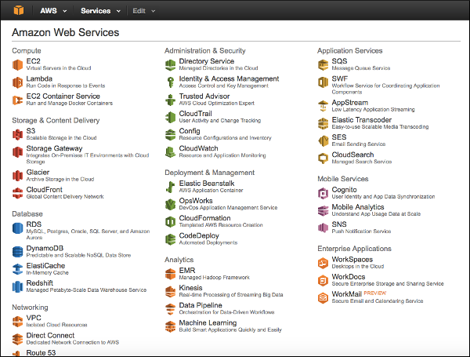
2. Navigate to your EC2 dashboard. Select **Instances** from the menu on the left side. 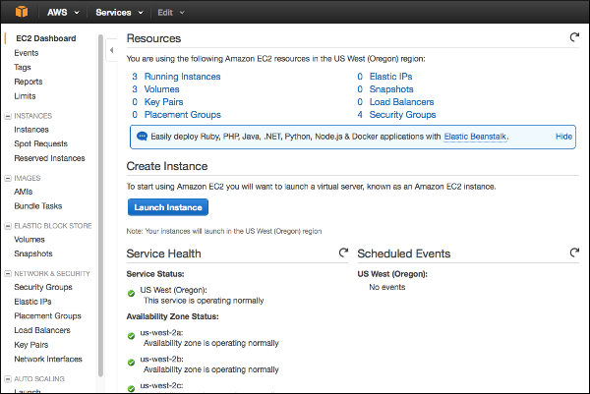
3. Terminate all your instances. 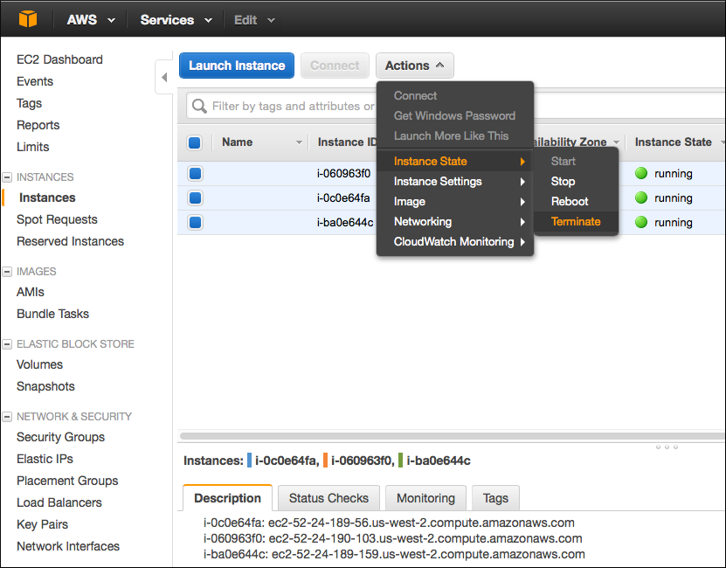
4. Select **Load Balancers**. Delete all load balancers. 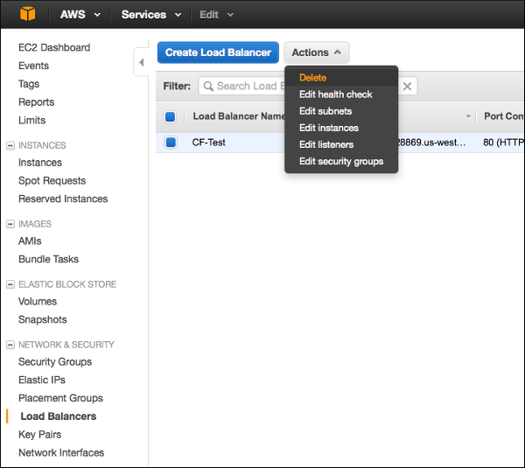
5. From the AWS Console, select **RDS**. 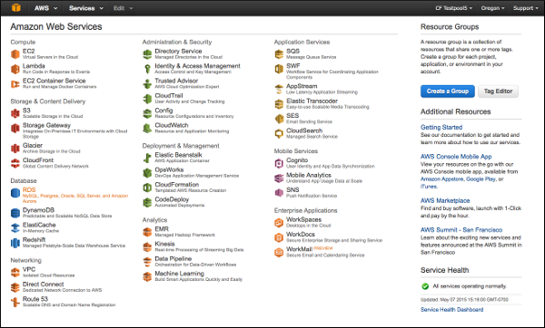
6. Select **Instances** from the menu on the left side. Delete the RDS instances. 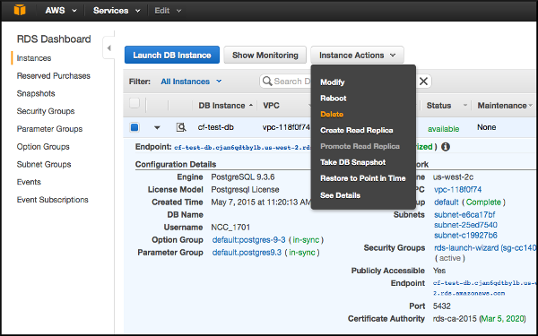
7. Select **Create final Snapshot** from the drop-down menu. Click **Delete**. 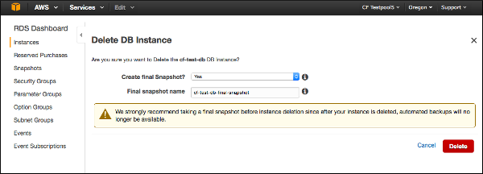
8. From the AWS Console, select **VPC**. 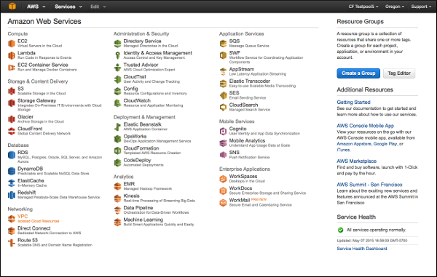
9. Select **Your VPCs** from the menu on the left. Delete the VPCs. 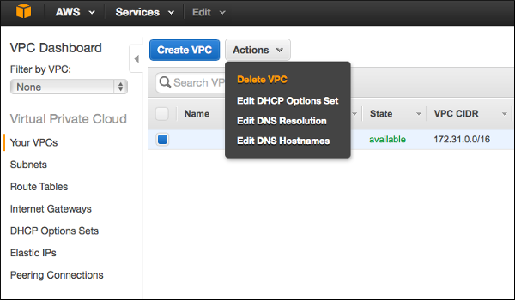
10. Check the box to acknowledge that you want to delete your default VPC. Click **Yes, Delete**. 